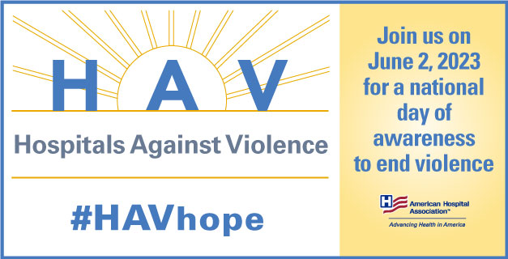

#HAVHope Friday and Save Act, June 2, 2023 Social Media Toolkit
Summary: #HAVhope is a national day of awareness to highlight how America’s hospitals and health systems combat violence in their workplaces and communities. June 2nd marks the seventh annual Hospitals Against Violence #HAVhope Friday to highlight how hospitals and health systems continue working toward partnerships, innovations, and creative thinking to build a safe workplace and community.
We invite you to use #HAVHope to share what policies, procedures, or practices your organization is doing in this effort. By operating as a united front and sharing these best practices, our hospitals can forge a path for all to have hope.
Sample Social Media:
- #HAVHope addresses community violence such as human trafficking, gun violence, and mass violence incidents. Learn more about prevention strategies as we work to end violence in our communities together: aha.org/HAVhope
- Help combat the growing public health issue of violence by learning more about #HAVHope. Find resources and information here: www.aha.org/HAVhope
- #HAVHope works with the field to highlight successful programs and practices that are committed to creating safe health care settings. The framework, "Building a Safe Workplace and Community" promotes the four pillars necessary for implementing a comprehensive violence mitigation strategy. Learn more: aha.org/HAVhope

Join the campaign – copy and tweet
- Join your community hospital for a national day of awareness of how health care organizations are combating violence in their workplace. #HAVHope
- What practices is your hospital or health system doing to bring awareness to or promote community violence prevention and workplace safety? Share your story with #HAVhope
- I’m joining my hospital with a commitment to mitigate violence in our hospitals & workforce. Together, we join @ahahospitals today to raise awareness & find solutions. #HAVHope
- Hospitals work with community members to cultivate a safe environment for their workforce and patients. Join us on June 2 to raise awareness of the work hospitals are doing to combat violence #HAVHope
- All forms of violence affect your community. Take a stand against workplace and community violence by joining forces with hospitals and health systems in #HAVhope Friday, a national day of awareness to end violence.

Copy and Retweet @AHAHospitals to show your support leading up to #HAVHope on June 2.
- #HAVhope is a national day of awareness to highlight how America’s hospitals and health systems combat violence in their workplaces and communities. Join @ahahospitals on June 2nd and take a stand against workplace and community violence.

#HAVHope Giphy Library
On platforms that use Giphy and Gifs search for “HAVHope” to populate #HAVhope campaign gifs.
Access gifs and share
Support #HAVHope on Instagram with our Instagram Story video: https://www.canva.com/design/DAFdv0tTTB0/Sp6s9glqGvtirXVq30HoMg/watch?utm_content=DAFdv0tTTB0&utm_campaign=designshare&utm_medium=link&utm_source=publishsharelink
Additional images can be found here: https://drive.google.com/drive/folders/1f4SkmnvJJlNdItAJpiuerFioMSwU5hFc
GRAPHICS:
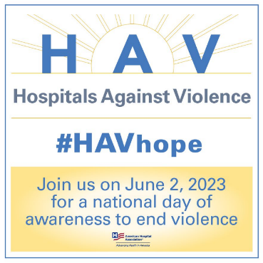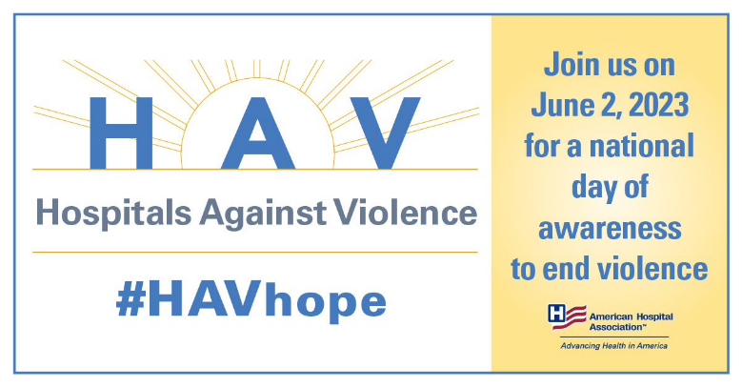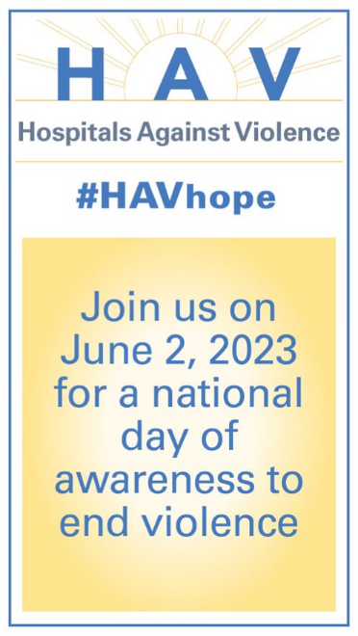

Save Act

Executive Summary: Congress has introduced a bill to offer the same legal protections to health care professionals that aircraft and airport professionals currently have, including criminal prosecutions for those who physically attack health care workers while they are performing their duties. The AHA wholeheartedly supports the passage of this bill and will actively advocate for its passage using social media and other media. This work is part of our larger efforts through the Hospitals Against Violence and #HAVHope prevention efforts.
In addition to AHA’s main Twitter account (as well as LinkedIn and Instagram), we will also use the AHA Advocacy Twitter account to thank the sponsors of the bill and encourage bipartisan work to pass the bill and send it to President Biden’s desk for signature into law.

Twitter Link: https://www.aha.org/workplace-violence?utm_source=twitter&utm_medium=organic&utm_campaign=workplace-violence-bill
Facebook: https://www.aha.org/workplace-violence?utm_source=facebook&utm_medium=organic&utm_campaign=workplace-violence-bill
LinkedIn: https://www.aha.org/workplace-violence?utm_source=facebook&utm_medium=organic&utm_campaign=workplace-violence-bill

Hashtag:
#HAVHope
Social Posts:
- The AHA applauds the introduction of the Safety from Violence for Healthcare Employees (SAVE) Act. Thank you to @RepLarryBucshon and @RepDean for sponsoring this vital legislation. We look forward to working with Congress to get this passed. #HAVHope
- The AHA supports the passage of the recently introduced Safety from Violence for Healthcare Employees (SAVE) Act. Support this legislation and learn more about creating safer health care workplace, including a guide created in conjunction with @IAHSS #HAVHope <link>
- The AHA looks forward to working with Congress to pass the SAVE Act. The AHA has several resources to help hospitals and health systems enhance protections for their employees #HAVHope <link>
- Hospitals and health systems across the country have invested resources and time into protecting their workforce. The Safety from Violence for Healthcare Employees (SAVE) Act will bolster those protections. Learn how some AHA member hospitals are working to ensure a safe workplace #HAVHope: https://www.aha.org/2021-12-03-workforce-and-workplace-violence-prevention-case-studies (NOTE: This will probably play best on LinkedIn)

- Three takeaways from the AHA supported SAVE Act:
  - The federal law will protect health care workers from assault or intimidation
  - This is a Bipartisan effort to support health care workers
  - The bill provides federal funding to help hospitals invest in efforts to reduce workplace violence, including through training programs and other resources

- Why should hospitals care about the SAVE Act? Health care workers shouldn’t be asked to provide attentive care to patients while fearing for their safety at the same time due to disruptive people. RT and show your support

- Thanks to the SAVE Act, health care workers can feel safer going to work without fear of violent attacks while they provide necessary care for their patients. RT and show your support

- The Safety from Violence for Healthcare Employees (SAVE) Act will protect America’s health care workers in the workplace by providing protections like those in the federal statute that criminalizes the assault and intimidation of aircraft and airport workers. We believe the hardworking staff at our hospitals and health systems deserve those same legal protections.

- According to the Bureau of Labor Statistics, health care workers are 5x more likely to be physically attacked on the job. Help end this issue by supporting the SAVE Act now: <link>

- Did you know that health care workers are victims of violence in the workplace? Studies indicate that in the last two years, 44% of nurses reported being subject to physical violence and 68% reported verbal abuse. Learn more about the SAVE Act which hopes to end this trend: <link>

- Workplace violence harms health care workers, and many suffer from both physical and psychological trauma after an incident. Let’s end this together by supporting the SAVE Act: <link>

- We are proud to partner with @ahahospitals to promote #HAVHope Friday and to spotlight the work hospitals and health systems are doing to address the public heath challenge of violence. Learn more:
- The AHA’s #HAVHope Day of Awareness has spotlighted that violence is a public health crisis – including violence against health care workers. We are proud to partner with the @ahahospitals to advocate for the passage of the #SAVEAct

- America’s hospitals and health systems thank @RepLarryBucshon and @RepDean for co-sponsoring the #SAVEAct and urge Congress to pass this vital piece of legislation to help protect our fellow health care workers from violence. #HAVHope
- America’s health care workforce deserves to come to work free from the fear of violence. As we partner with @ahahospitals to observe #HAVHope Day on June 2, we urge the passage of the #SAVEAct, which would increase penalties for attacking health care professionals.
- As we partner with @ahahospitals to observe #HAVHope Friday on June 2, we urge Congress to pass the #SAVEAct, which will help strengthen protections for health care workers who become victims of violence.
- As AHA Chief Nursing Officer Robyn Begley recently said, protecting the nation’s caregivers must be a national priority. As we join with @ahahospitals to mark #HAVHope Friday, we urge Congress to pass the #SAVEAct to help protect our health care colleagues. @tweetAONL

Graphics: https://drive.google.com/drive/folders/19MTN14idnUWHUq7_iqs0j11v0t_Af7Xe?usp=sharing
Images:
Building a Safe Workplace and Community PDF, turning into an infographic: https://www.aha.org/system/files/media/file/2021/10/building-a-safe-workplace-and-community-framework-for-hospitals-and-health-systems.pdf

