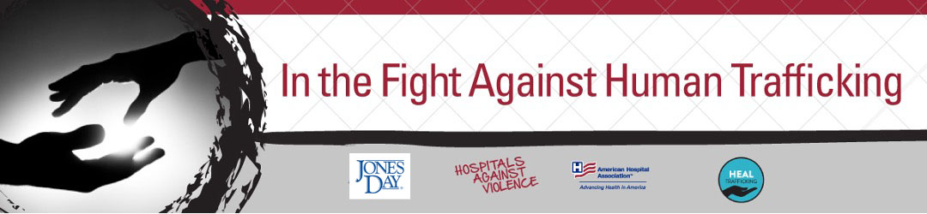
National Human Trafficking Awareness Month digital toolkit
January 11th is designated as National Day of Human Trafficking Awareness, and January is National Human Trafficking Prevention Month. The purpose of this toolkit is to raise awareness on the various types of human trafficking and to provide hospitals and health systems with resources to combat human trafficking in health care settings. With videos, graphics and posts in both English and Spanish, this toolkit is a resource for AHA members and all organizations in the fight against human trafficking.
Content and Graphics for use on Twitter/LinkedIn/Facebook
Labor trafficking is a form of #humantrafficking. Health care workers can effectively assess risk and improve victim identification and response by looking for these signs️. #HumanTraffickingAwarenessMonth #HAVhope #HEALTrafficking https://www.aha.org/education-events/reality-labor-trafficking-webinar-replay
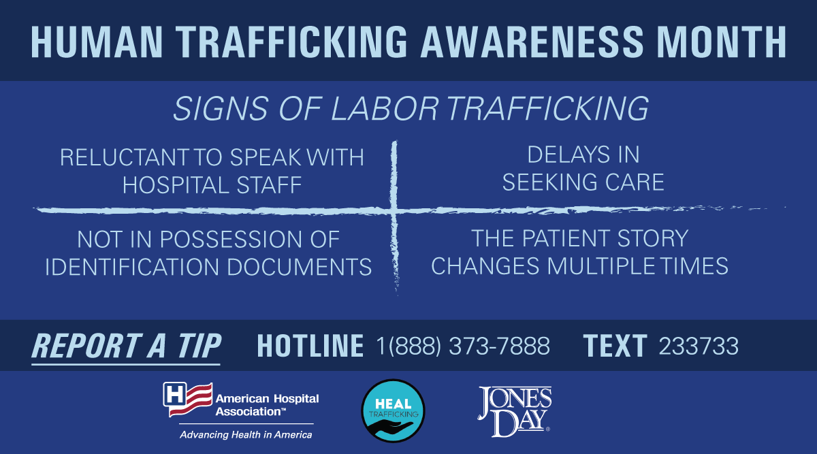
Spanish Translation: La trata laboral es una forma de #tratadepersonas. Los profesionales de salud pueden evaluar riesgos, identificar y responder notando estas señales. #HumanTraffickingAwarenessMonth #HAVhope #HEALTrafficking https://www.aha.org/education-events/reality-labor-trafficking-webinar-replay

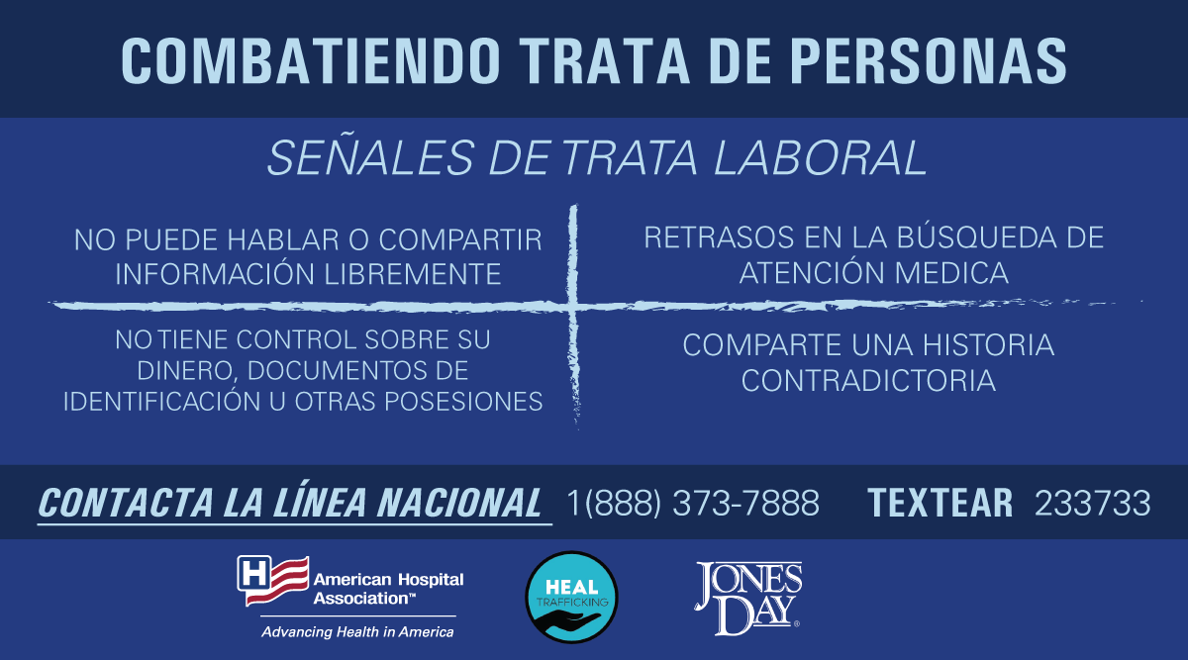

Labor trafficking situations include forced labor because of debt, immigration status, and threats of violence. Health care workers can assess risk and improve victim identification by looking for these indicators. #HumanTraffickingAwarenessMonth #HAVhope https://www.aha.org/combating-human-trafficking
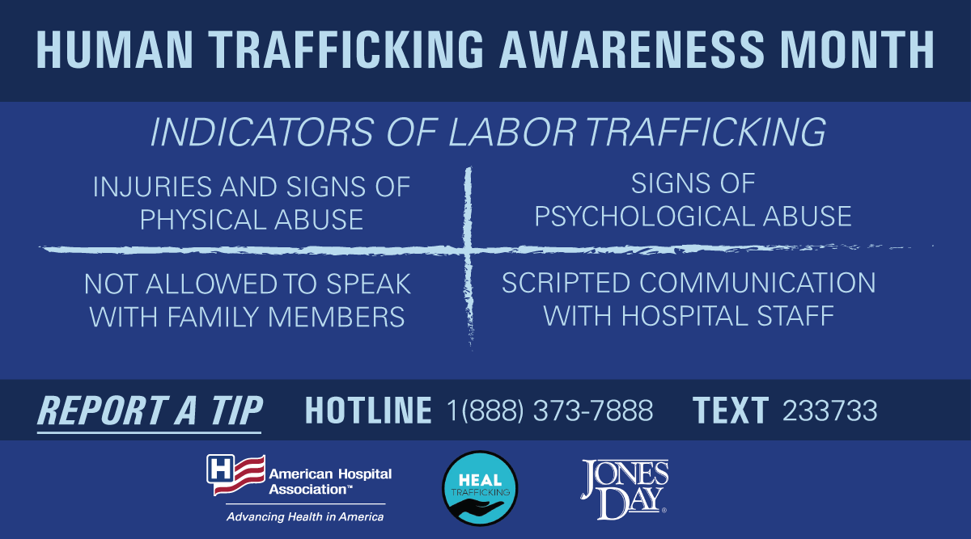
Spanish Translation: Los traficantes usan el abuso, mentiras, amenazas y violencia para que personas trabajen contra su voluntad. Los profesionales de salud pueden identificar y evaluar el riesgo de las víctimas de trata de personas buscando estos indicadores. #HumanTraffickingAwarenessMonth #HAVhope https://www.aha.org/combating-human-trafficking

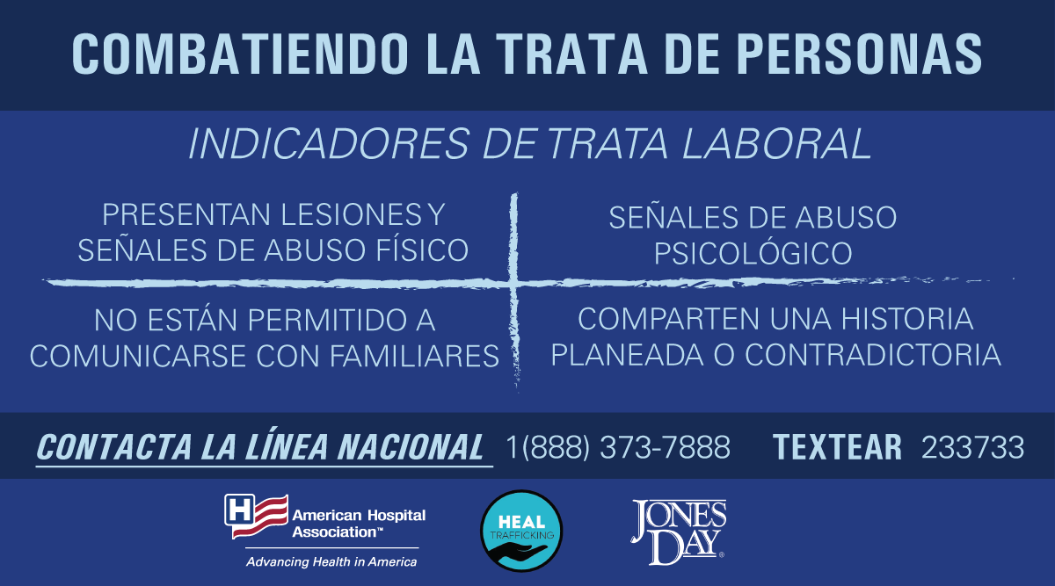

Children can be victims of labor trafficking. They may be runaway or homeless youth, unaccompanied minors, forced to working in agriculture or sell drugs. Health care workers can improve victim identification by looking for these signs. #HumanTraffickingAwarenessMonth #HAVhope https://www.aha.org/combating-human-trafficking
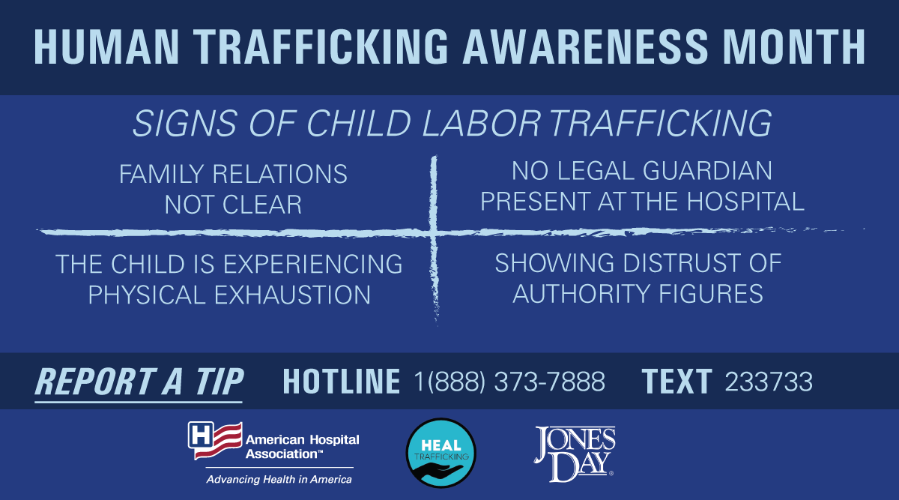
Spanish Translation: Los niños y las niñas pueden ser víctimas de la trata laboral. Pueden ser personas sin hogar, jóvenes que huyen o menores no acompañados. Comprender las señales >>> https://www.aha.org/combating-human-trafficking #HumanTraffickingAwarenessMonth #HAVhope

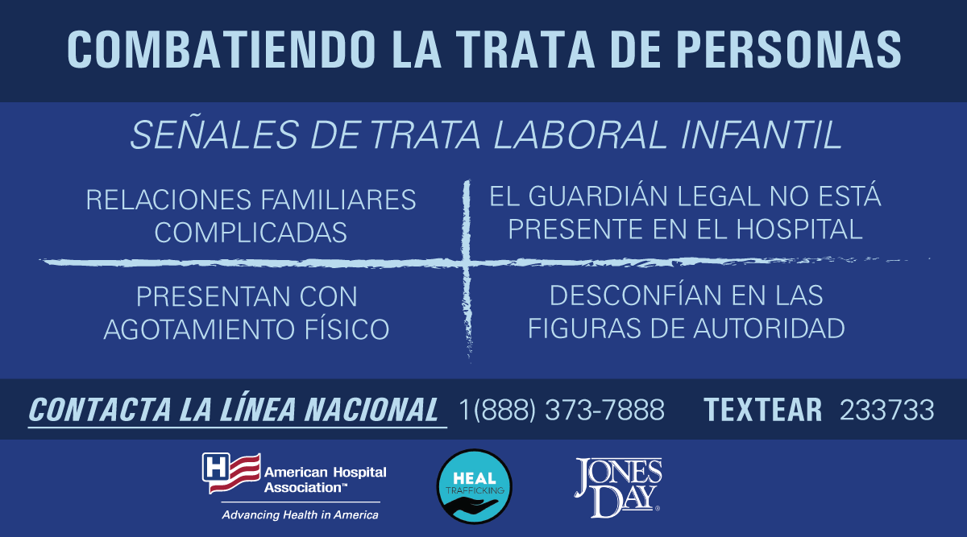

Health care workers can help combat human trafficking by identifying signs from patients and reporting tips. Save this phone number to your contacts to report tips for human trafficking 1-888-373-7888. #HumanTraffickingAwarenessMonth #HAVhope https://www.aha.org/combating-human-trafficking
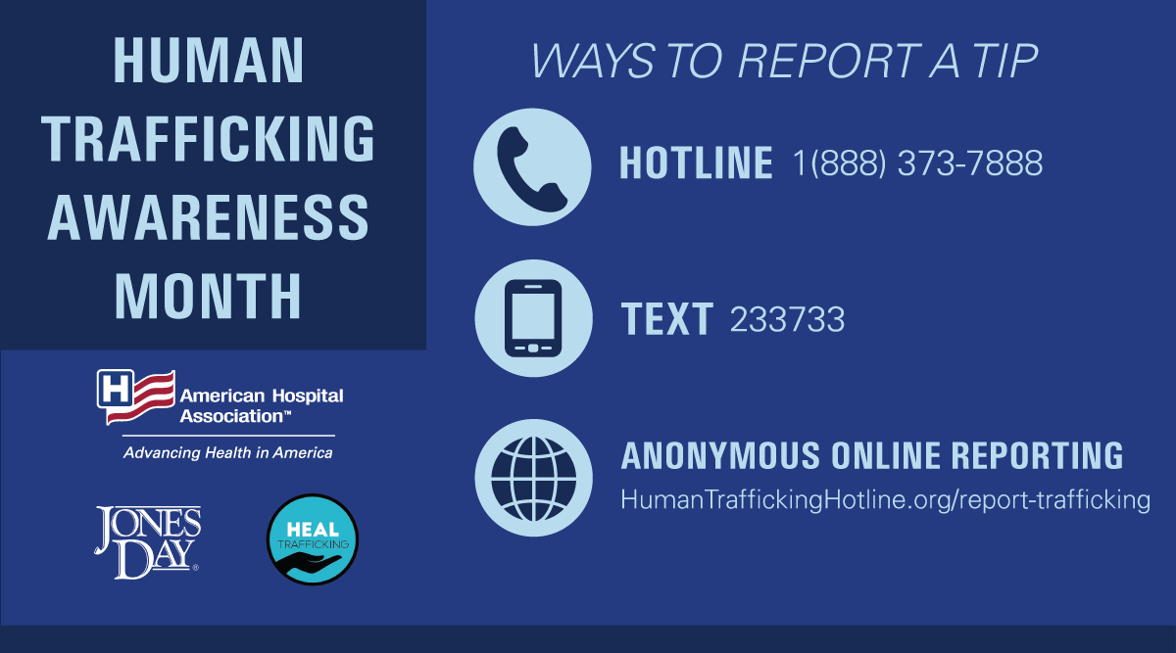
Spanish Translation: Profesionales de salud pueden combatir la trata de personas identificando las señales y reportando a la línea nacional contra la trata de personas. Guarda esta información para obtener ayuda y avisar a las autoridades. #HumanTraffickingAwarenessMonth https://www.aha.org/combating-human-trafficking

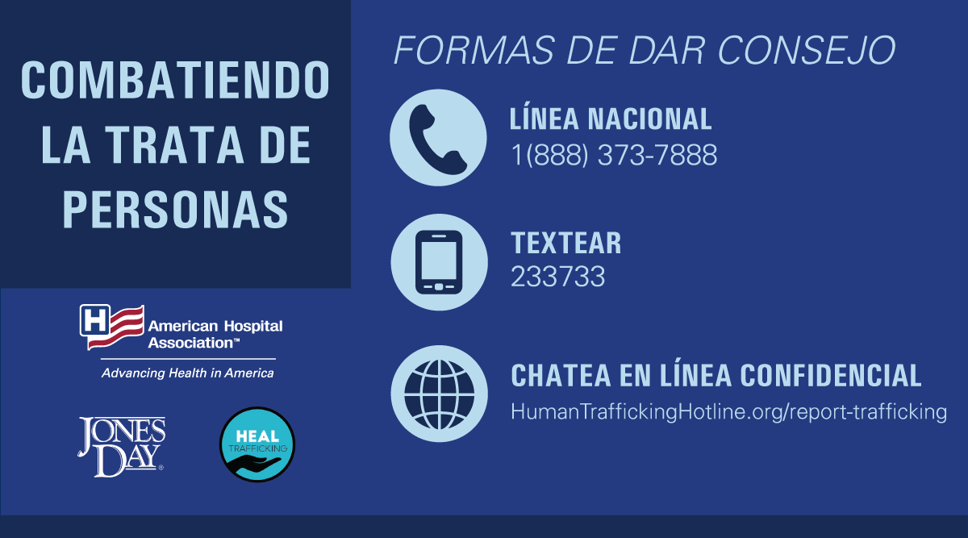

Learn about 10 Red Flags that your patient could be a victim of human trafficking. Health care professionals have an important role in providing trauma-informed patient care and looking for these signs improves the identification and response to human trafficking. #HumanTraffickingAwarenessMonth #HAVhope https://www.aha.org/infographics/10-red-flags-your-patient-could-be-victim-human
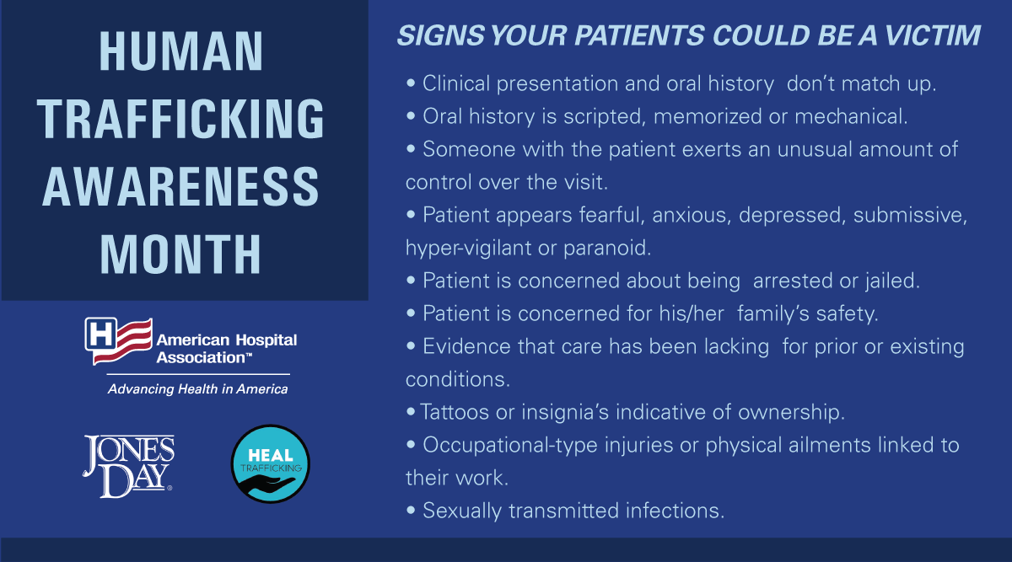
Spanish Translation: Descubre las 10 señales de advertencia que el paciente podría ser víctima de trata de personas. Profesionales de salud tienen un papel importante en proveer atención medica informado sobre el trauma y reconociendo las señales de la trata de personas. https://www.aha.org/infographics/10-red-flags-your-patient-could-be-victim-human
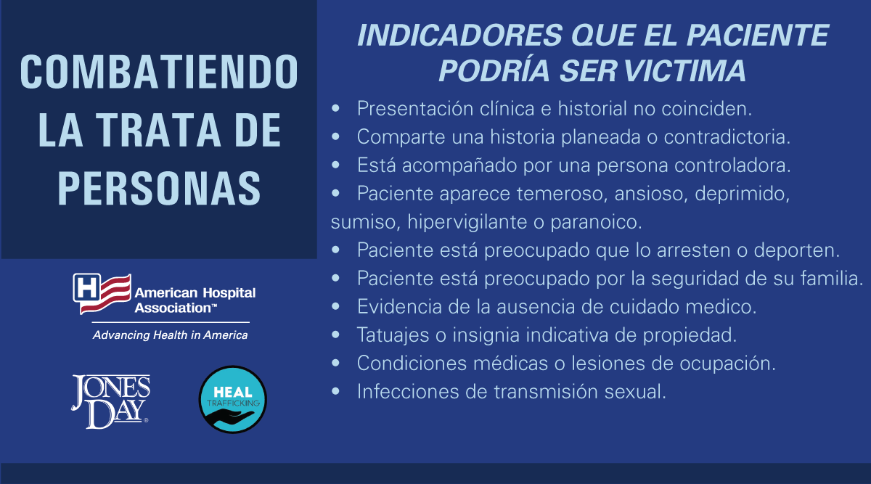

The PEARR Tool is an evidence-based framework for health care workers to use when assessing for human trafficking. With this tool health care workers can have informative conversation with patients to build context and possibly accept assistance. #HumanTraffickingAwareness #HAVhope https://healtrafficking.org/resources/pearr-tool/

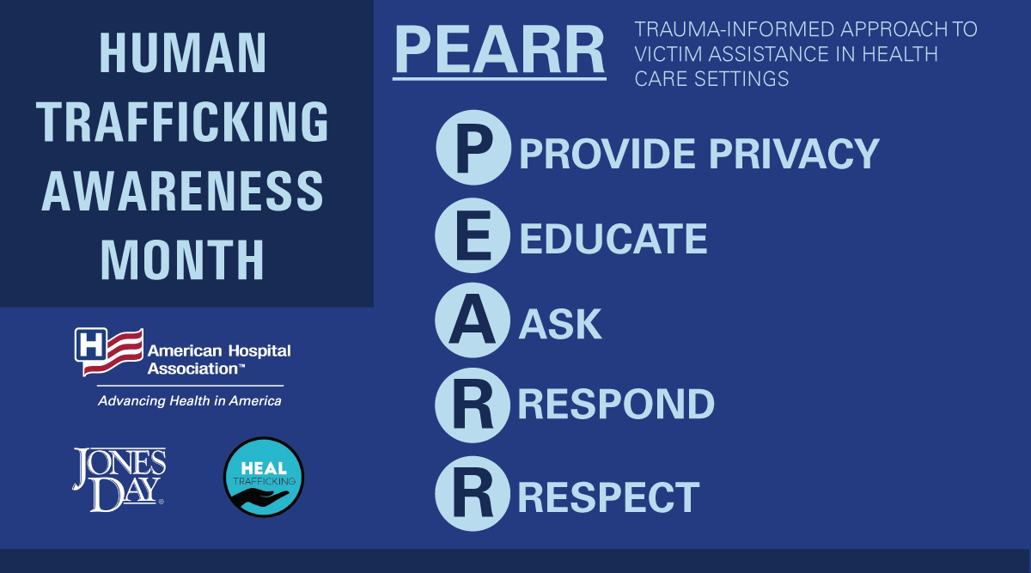

Spanish Translation: “PEARR” es un recurso basado en evidencia para evaluar la posibilidad de trata de personas. Con #PEARR proveedores de atención medica pueden hablar francamente con los pacientes para que reciban el mejor cuidado médico. #HumanTraffickingAwareness #HAVhope https://healtrafficking.org/resources/pearr-tool/

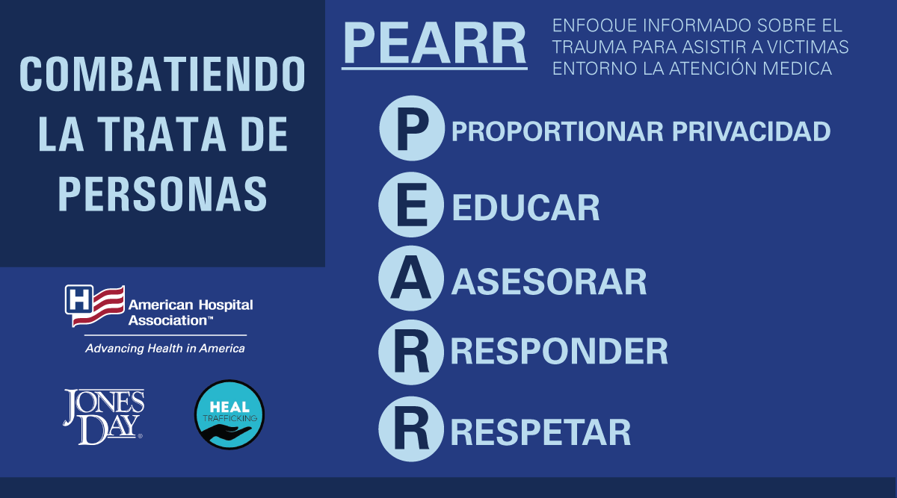

We have collaborated with organizations, like @HEALTrafficking, to create resources to aid health care workers to fight #humantrafficking, including a tool from @JonesDay to help providers with human trafficking reporting and education obligations. #HumanTraffickingAwareness #HAVhope https://www.aha.org/guidesreports/2021-01-08-legal-requirements-reporting-and-education-human-trafficking-and-health?utm_source=twitter&utm_medium=organic&utm_campaign=hta-month&utm_term=jonesday

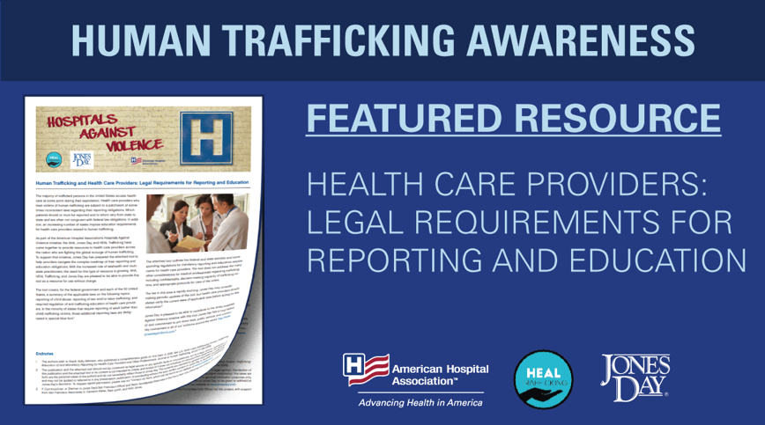

Spanish Translation Hemos colaborado con organizaciones como @HEALTrafficking, para crear recursos para que profesionales de salud puedan combatir la trata de personas, incluyendo un recurso de @JonesDay para asistir con obligaciones de educación y reportar. #HAVhope https://www.aha.org/guidesreports/2021-01-08-legal-requirements-reporting-and-education-human-trafficking-and-health?utm_source=twitter&utm_medium=organic&utm_campaign=hta-month&utm_term=jonesday

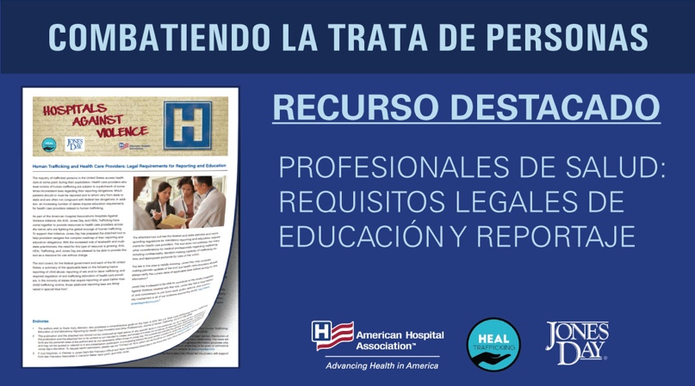
Get the facts on the ICD-10 codes for classifying #humantrafficking. These codes are available for data collection on adult or child forced labor or sexual exploitation, either confirmed or suspected. https://www.aha.org/factsheet/2018-factsheet-icd-10-coding-human-trafficking?utm_source=twitter&utm_medium=organic&utm_campaign=hta-month&utm_term=icd-10

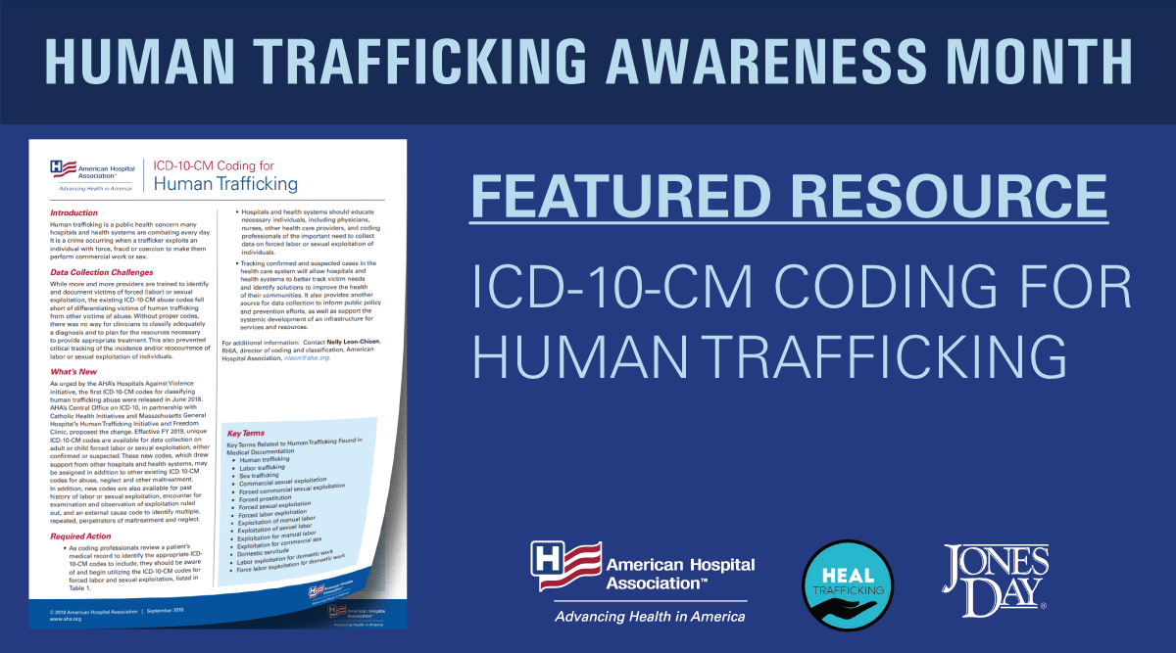

Spanish Translation: Más información disponible acerca de los códigos de ICD-10 para clasificar la trata de personas #HumanTrafficking. Estos códigos están disponibles para la recopilación de datos. #HumanTraffickingAwarenessMonth #HAVhope https://www.aha.org/factsheet/2018-factsheet-icd-10-coding-human-trafficking?utm_source=twitter&utm_medium=organic&utm_campaign=hta-month&utm_term=icd-10

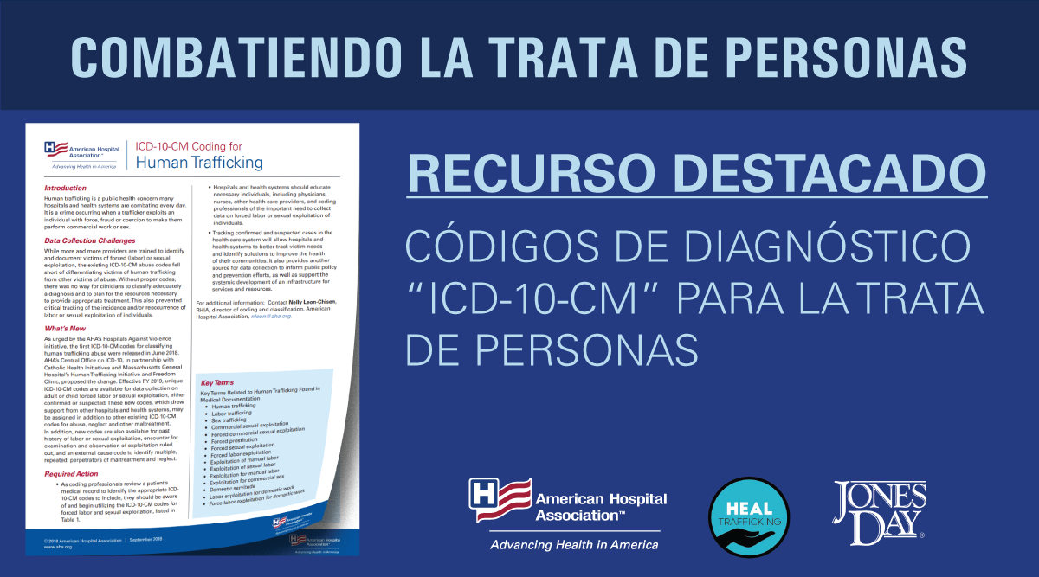

General Posts

Health care workers can lead the effort in improving identification and reporting of human trafficking. Follow the best practices for screening, assessing, and helping victims of human trafficking. #HumanTraffickingAwarenessMonth For resources visit >>> https://www.aha.org/fight-against-human-trafficking?utm_source=twitter&utm_medium=organic&utm_campaign=hta-month&utm_term=resources

Spanish Translations: Profesionales de salud pueden dirigir los esfuerzos para mejorar la identificación y reportaje de victimas de trata de personas. Para más información https://www.aha.org/fight-against-human-trafficking?utm_source=twitter&utm_medium=organic&utm_campaign=hta-month&utm_term=launch #HumanTraffickingAwarenessMonth #HAVhope

January is #HumanTraffickingAwarenessMonth. AHA #HAVhope resources are available to help #hospitals and health care workers prevent human trafficking: https://www.aha.org/fight-against-human-trafficking?utm_source=twitter&utm_medium=organic&utm_campaign=hta-month&utm_term=launch

Spanish Translations: Enero esta designado #HumanTraffickingAwarenessMonth para informar él publico acerca de la trata de personas. Recursos de AHA #HAVhope están disponibles para ayudar a #hospitales y profesionales de salud prevenir la trata de personas: https://www.aha.org/fight-against-human-trafficking?utm_source=twitter&utm_medium=organic&utm_campaign=hta-month&utm_term=launch

