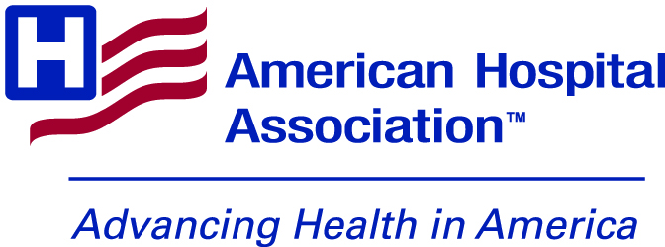

Suicide Prevention Month Toolkit

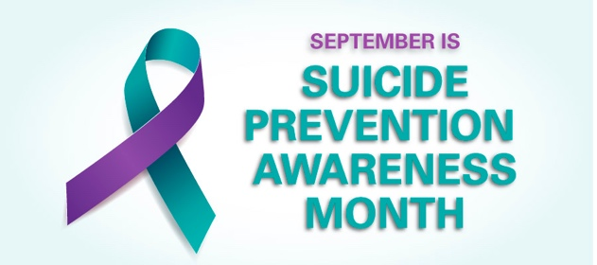
LINKS:

Hashtags: #SuicidePreventionMonth

General Link: https://www.aha.org/suicideprevention

TWITTER:
https://www.aha.org/suicideprevention?utm_source=twitter&utm_medium=organic&utm_campaign=suicide-prevention-month-2022

FACEBOOK:

https://www.aha.org/suicideprevention?utm_source=facebook&utm_medium=organic&utm_campaign=suicide-prevention-month-2022

LINKEDIN:

https://www.aha.org/suicideprevention?utm_source=linkedin&utm_medium=organic&utm_campaign=suicide-prevention-month-2022

Images (Including People Matter Words Matter): https://drive.google.com/drive/folders/1nW15oZOcDx6gaqR78e05m1dMmEtR1yAO?usp=sharing

Suicide Prevention Month Posts:

- The 988 Lifeline helps thousands of struggling people overcome suicidal crisis or mental-health related distress every day. The AHA has resources for those who want to learn more about the new 988 crisis line #SuicidePreventionMonth
- Why Boards Should Focus on Suicide Prevention https://trustees.aha.org/why-boards-should-focus-suicide-prevention #SuicidePreventionMonth
- Listen to this Advancing Health podcast to hear a panel discussion about the issues facing rural health care providers – including how they are addressing behavioral health issues: https://soundcloud.com/advancinghealth/aha-celebrates-national-rural-health-day #SuicidePreventionMonth

- As we observe #SuicidePreventionMonth, check out this podcast series, co-developed by the AHA’s Physician Alliance and the Education Development Center, featuring stories of recovery and ideas for supporting colleagues struggling with thoughts of suicide: https://www.aha.org/advancing-health-podcast/be-well-preventing-physician-suicide
- In this 2018 webinar, Susan Kimper, director, Behavioral Health Naples Community Hospital (NCH) Healthcare System discusses patient-centered safety plans for suicidal patients. You can listen here: https://www.aha.org/webinars/2018-08-30-nch-healthcare-system-naples-fl-putting-patient-back-drivers-seat-safe #SuicidePreventionMonth
- How Respectful Dialogue Can Reduce Mental Health Stigma: https://www.aha.org/news/blog/2022-07-13-how-respectful-dialogue-can-reduce-mental-health-stigma #SuicidePreventionMonth
- 988: Transforming America’s Behavioral Health Safety Net https://www.aha.org/news/blog/2022-07-18-988-transforming-americas-behavioral-health-safety-net #SuicidePreventionMonth
- TrendWatch: The Impacts of the COVID-19 Pandemic on Behavioral Health: https://www.aha.org/guidesreports/2022-05-31-trendwatch-impacts-covid-19-pandemic-behavioral-health #SuicidePreventionMonth
- DYK: Regional behavioral health care networks and community partnerships can reduce wait times for outpatient services by 50%? They are also associated with improved care outcomes. Download the AHA's executive summary on these networks. #SuicidePreventionMonth https://www.aha.org/regional-networks-behavioral-health-improving-access-care
- As we observe #SuicidePreventionMonth, be sure to check out the @AHAPhysAlliance Clinician Well-Being Playbook, which can help hospital leaders provide support for physicians who might be struggling with burnout: https://www.aha.org/physicians/well-playbook

PEOPLE MATTER WORDS MATTER SUICIDE PREVENTION POSTER

LINKS:

TWITTER: https://www.aha.org/people-matter-words-matter?utm_source=twitter&utm_medium=organic&utm_campaign=people-matter-suicide-prevention&utm_content=behavioral-health

FACEBOOK: https://www.aha.org/people-matter-words-matter?utm_source=facebook&utm_medium=organic&utm_campaign=people-matter-suicide-prevention&utm_content=behavioral-health

LINKEDIN: https://www.aha.org/people-matter-words-matter?utm_source=linkedin&utm_medium=organic&utm_campaign=people-matter-suicide-prevention&utm_content=behavioral-health

- The topic of suicide, and the sometimes-stigmatizing language around it, must be handled with compassion. Download this #PeopleMatterWordsMatter poster to learn how health care professionals can discuss this sensitive issue. #SuicidePreventionMonth
- Joking about or using suicide in hyperbolic manner can increase stigma. This #PeopleMatterWordsMatter poster focuses on using more compassionate language when talking about suicide, which can lead to more people seeking treatment. #SuicidePreventionMonth

- Talking about suicidal thoughts is an important first step for someone with suicidal ideation and can lead to seeking professional help. Check out this #PeopleMatterWordsMatter poster for ways to use more compassionate language to help patients feel comfortable in discussing behavioral health issues. #SuicidePreventionMonth

- Talking about thoughts of suicide reduces its stigma and normalizes these conversations, allowing for open conversations that can lead to the person seeking help. Download this #PeopleMatterWordsMatter poster for more. #SuicidePreventionMonth

- If you heard, “Someone who really wants to end their life is beyond help, and there’s nothing we can do,” how would you respond? Download this #PeopleMatterWordsMatter poster to learn how to change the conversation around suicide. #SuicidePreventionMonth

- The topic of suicide, and the sometimes-stigmatizing language around it, must be handled with compassion. The language you use can be an important factor in whether or not a person seeks care. Download this #PeopleMatterWordsMatter poster for more. #SuicidePreventionMonth

IMAGES:

