The American Hospital Association is celebrating Community Health Improvement (CHI) Week from June 2-8, 2019. CHI Week is a national event to recognize the important role hospitals, health systems and communities have in advancing health and well-being. CHI Week raises awareness, demonstrates impact and celebrates the individuals and organizations that are working together to advance the health and well-being of their communities. AHA will release multiple resources aligning with the theme of the week: One Voice to Activate Partnerships. Resources include guides, blogs, webinars and podcasts to help advance your community health improvement and population health work.
Visit aha.org/chiweek for more information.
AHA encourages you to promote CHI Week via social media.
AHA/ACHI Social Media:
- Twitter: @ahahospitals @communityhlth
- LinkedIn: https://www.linkedin.com/company/american-hospital-association https://www.linkedin.com/groups/104598/
- Facebook: @ahahospitals @communityhlth
**Please follow @ahahospitals and @communityhlth to view daily updates during CHI Week
**Please use the hashtag #chiweek when posting on social media, and tag @ahahospitals and @communityhlth.

Facebook/LinkedIn:
The American Hospital Association invites you to celebrate Community Health Improvement (CHI) Week, June 2-8, 2019. CHI Week is a national event to raise awareness about community health and population health resources, demonstrate impact and celebrate the passion and dedication of individuals and organizations that work to improve the health and well-being of their communities. AHA will release multiple resources such as guides, webinars and tools throughout the week, aligning with the theme of the week: One Voice to Activate Partnerships. Visit aha.org/chiweek for more information.
- Follow @ahahospitals and @communityhlth for daily CHI Week updates
- Celebrate with us on social media! Use #chiweek and share what your organization is doing to celebrate CHI Week!
- Have a community health improvement success story? Email achi@aha.org to be featured on our website!

Sample Tweets before CHI Week
- Join @ahahospitals @communityhlth in celebrating the 2019 #chiweek, June 2-8
- Share your community health improvement story with @ahahospitals @communityhlth during #chiweek
- What’s happening during #chiweek? Check out the website for more information. https://www.aha.org/chiweek

Sample Tweets during CHI Week
- Tuned in for @ahahospitals webinar on June 3 "Creating a Culture of Population Health", part of celebrations for #chiweek!
- How have you participated in @ahahospitals #chiweek? Share your stories, pictures and tweets!
- Let’s activate new partnerships during #chiweek
- Check out new resources from @ahahospitals during #chiweek
CHI Week Webinar

Facebook/LinkedIN:
Join the AHA to kick off Community Health Improvement Week on Monday, June 3 to discuss how partnerships around population health can drive organizational and community transformation. Leaders from Intermountain Healthcare and Atrium Health will share their hospitals’ respective journeys to integrate population health as an organizational mission. Register here.
Registration link: https://ahahealthforum.adobeconnect.com/pophealth6-03-19/event/registration.html?campaign-id=Invitation+%231

Sample Tweets:
- Interested in ingraining population health goals into a hospital’s mission and values? Join the #chiweek webinar on June 3 to hear from leaders in the field. Register today! @AlisahahMD @AtriumHealth @mikellemoore @Intermountain @ahahospitals @communityhlth #communityhealth #populationhealth
- Register for the upcoming June 3 #chiweek webinar to learn how you can create better partnerships to support your population health goals! Register here. @AlisahahMD @AtriumHealth @mikellemoore @Intermountain @ahahospitals @communityhlth #communityhealth #populationhealth
- One week left! Register for June 3 #chiweek webinar on Creating a Culture of Population Health at your organization. Register here. @AlisahahMD @AtriumHealth @mikellemoore @Intermountain @ahahospitals @communityhlth #communityhealth #populationhealth
- Two days left and spots are filling up! Register today to learn how your hospital integrate population health as an organizational mission #chiweek @AlisahahMD @AtriumHealth @mikellemoore @Intermountain @ahahospitals @communityhlth #communityhealth #populationhealth

SHARE GRAPHICS

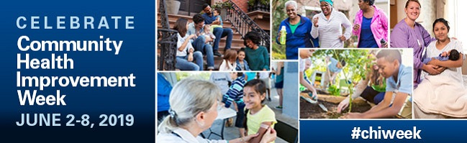

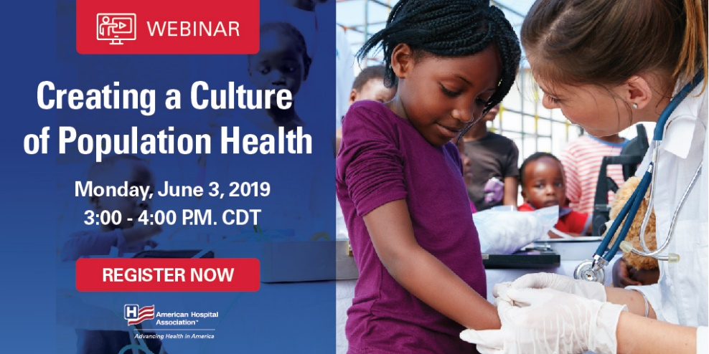

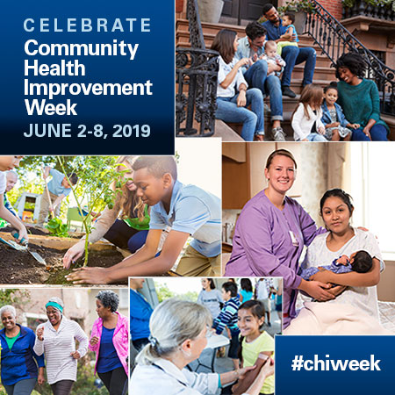

Please contact Syeda Aisha at saisha@aha.org with any questions.

