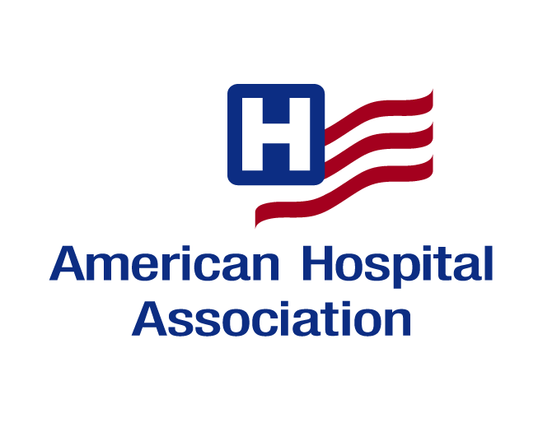**AHA Member Conference Call**

**Meaningful Use: Stage 2 Regulations - Hospitals**

**October 17, 2012**

**CONFERENCE CALL Follow-up**

1. Request for additional information: _________________________________________________

_________________________________________________________________________________

_________________________________________________________________________________

2. Questions or comments: __________________________________________________________

_________________________________________________________________________________

_________________________________________________________________________________

### 3. Evaluation: Strongly Strongly

### Agree Disagree

1. The call was informative and worthwhile. 5 4 3 2 1
2. The call addressed issues I expected to hear about. 5 4 3 2 1
3. There was ample time on the call to ask questions 5 4 3 2 1

or make comments.

-------------------------------------------------------------------------------------------------------------------

Name: _____________________________________________________________

Title: _____________________________________________________________

Organization: ________________________________________________________

Address: ____________________________________________________________

City/State/Zip: _______________________________________________________

Phone: ____________________________Fax: _____________________________

E-mail: _____________________________________________________________

#### Please return this form to Evelyn Gutierrez

#### 312-268-6269 (FAX)