Communications Plan for #HAVhope

Suggested graphics:
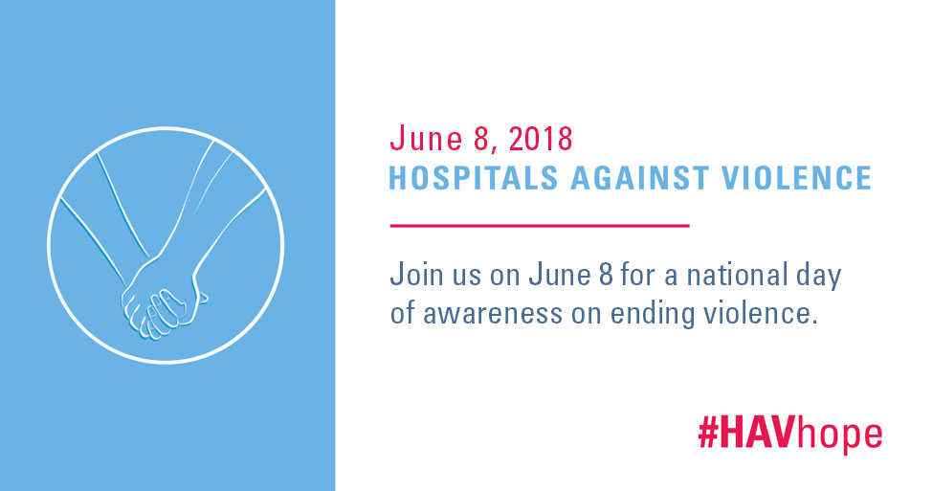

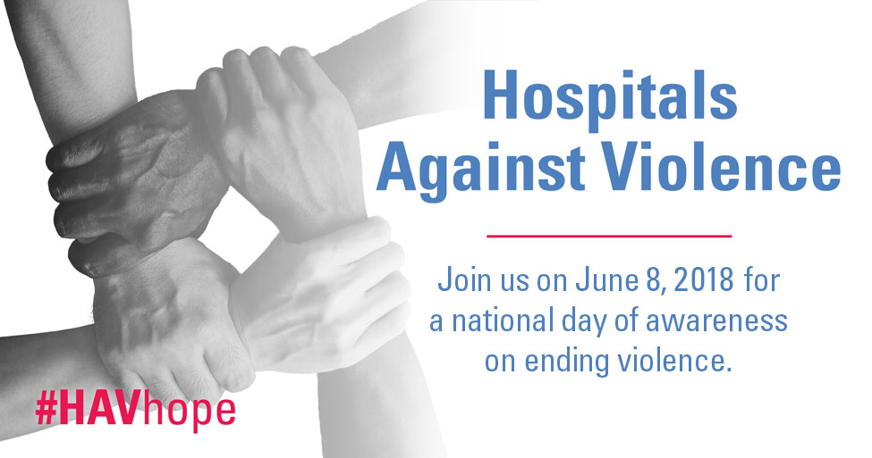

Content for June 8 #HAVhope:

Twitter:

Join us for a national day of awareness on June 8 to end all forms of violence. Learn how to participate. #HAVhope http://ow.ly/IQQs30iHtPq

#HAVhope is a national day of awareness on 6/8 calling for an end to all violence. Learn how to join in. http://ow.ly/IQQs30iHtPq

Stand up to end violence by taking part in #HAVhope, a national day of awareness on 6/8. Find out how to take part: http://ow.ly/IQQs30iHtPq

Join hospitals and health systems in standing up to violence on 6/8. Learn about #HAVhope and how to participate: http://ow.ly/IQQs30iHtPq

Facebook:

Violence is a growing public health and safety issue throughout the country. Join us in a national day of awareness, #HAVhope, on June 8 that calls for ending violence in all forms. Learn ways to participate here. http://ow.ly/IQQs30iHtPq

Please join us in an effort to end all forms of violence, a problem that plagues our communities. Find out how to participate in a national day of awareness #HAVhope on June 8. http://ow.ly/IQQs30iHtPq

Join hospitals and health systems in participating in #HAVhope, a national day of awareness on June 8, to end all forms of violence. Share a photo on June 8 of you holding hands with others in your community or workplace committed to combating violence.
http://ow.ly/IQQs30iHtPq

Take a stand against workplace and community violence by joining forces with hospitals and health systems in #HAVhope, a national day of awareness to end violence. Tag a picture of you holding hands with others in your community or workplace showing your commitment to combat violence. http://ow.ly/IQQs30iHtPq

