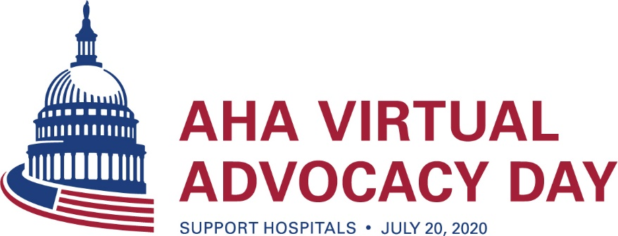

Digital Toolkit

On July 20, we encourage you to get online to contact your senators and ask them to include a number of important provisions in the next COVID-19 relief package to support front-line health care personnel and providers — including hospitals, health systems, physicians and nurses.

It is imperative that Congress provides additional relief to hospitals and health systems as recent reports estimate total losses for the nation’s hospitals and health systems as at least $323.1 billion in 2020.

The following broad provisions that cut across AHA membership should be included in the relief package:
- Additional support for health care heroes;
- Forgiveness for accelerated payments;
- Maintaining health benefits for individuals and families and increasing coverage options for those who are uninsured; and
- Appropriate liability protections to front-line medical providers and facilities.

To that end, we have crafted messages and accompanying graphics for you to use across your organization’s social media platforms. Remember to identify yourself as a constituent and tag your members of Congress, @AHAadvocacy and use #SupportHospitals in all your messages.

Messages

Twitter

- As the upcoming #COVID19 relief package is discussed, we ask Congress to #SupportHospitals.
- Congress must provide support for child care, housing, transportation and education benefits for #hospital workers in the next #COVID19 relief package. #SupportHospitals
- We urge our senators to #SupportHospitals by providing bonus pay for hospital workers and establishing a compensation fund 4 #COVID19 health care workers + their families.
- Forgiving #Medicare accelerated payments in the next #COVID19 relief package will provide a way for hospitals to recover and rebuild. – Ask Congress to #SupportHospitals
- Congress must take action to maintain health benefits for families and individuals, and they must increase coverage options for those who are uninsured. #SupportHospitals
- In the next #COVID19 relief package, Congress must provide appropriate liability protections for #hospitals and front-line medical providers – RT and #SupportHospitals
- #Hospitals and front-line medical workers need appropriate protections for arranging for and providing health care services – Join us and ask Congress to #SupportHospitals
- We urge Congress to #SupportHospitals in the upcoming COVID-19 relief package.
- Support our front-line health care workers fighting #COVID19 in our communities. Help our hospitals, health systems, caregivers and patients win this fight! #SupportHospitals
Facebook/LinkedIn/Instagram

- We urge Congress to #SupportHospitals in the next #COVID19 relief package by providing support for child care, housing, transportation and education benefits for hospital workers; providing bonus pay for hospital workers; and establishing a compensation fund for COVID-19 health care workers and their families.
- Join us and advocate for the next #COVID19 relief package to #SupportHospitals. Congress can maintain health benefits for individuals and families and increase coverage options for those who are already uninsured.
- Congress should provide #hospitals and front-line medical providers with appropriate liability protections during #COVID19 for arranging for and providing health care services (including where treatment is provided) and how best to deploy personnel, equipment and facilities. #SupportHospitals
- We urge our Congress members to #SupportHospitals and oppose burdensome and unrealistic OSHA provisions in the next #COVID19 relief package

Graphics

Twitter/LinkedIn
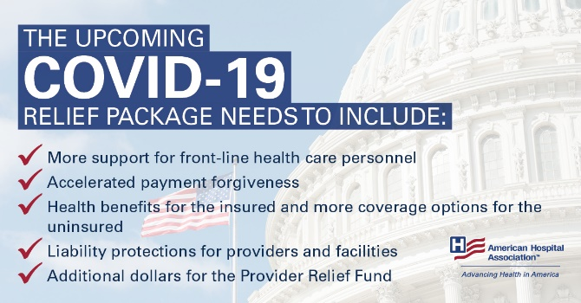
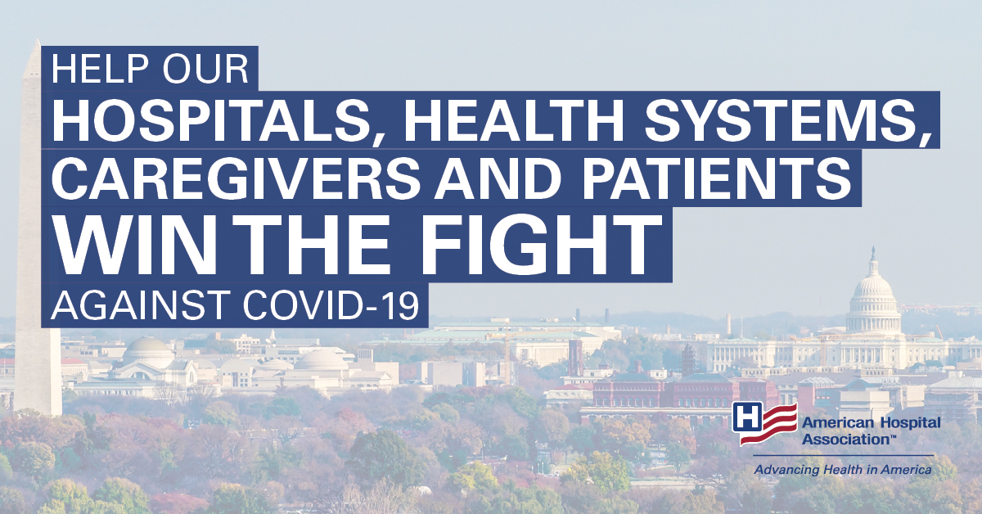

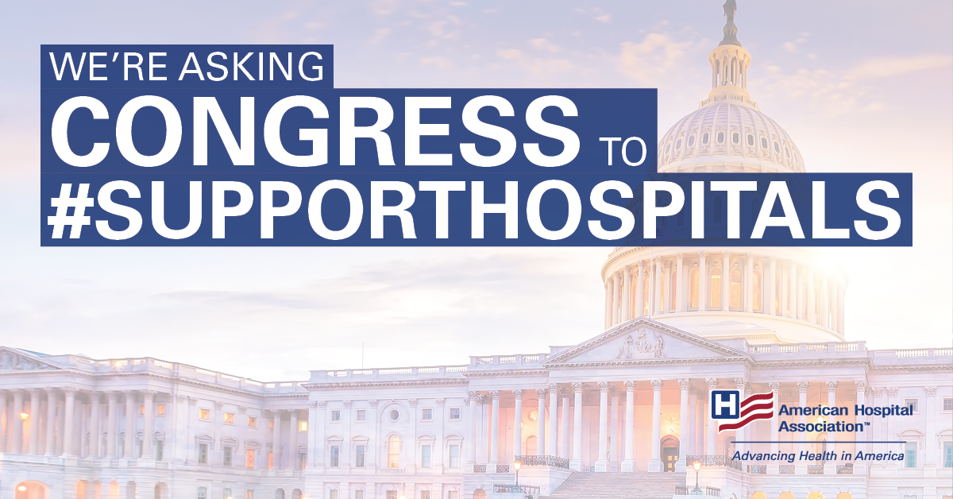

Facebook/Instagram
